**Insights Report**

**Customer Analysis**

* A total of 10 distinct customers placed 16 orders, covering 6 unique dishes.

**Order** **Timing**

* The majority of orders were placed during the night (dinner time).

**Top** **Dishes**

* The most popular dishes were Spaghetti and Grilled Chicken, both receiving the highest number of orders and top average ratings.
* Spaghetti had an average session time of 35 minutes, while Grilled Chicken recorded 42.5 minutes, making them the most engaging dishes.

**Revenue Contribution**

* Spaghetti generated the highest revenue at $56, followed by Grilled Chicken with $51.
* Oatmeal, commonly ordered during breakfast, had the lowest revenue of $7.

**Geographical Insights**

* The highest orders were placed by Alice, Bob, and Charlie from Chicago, Los Angeles, and New York, respectively.
* Chicago, Los Angeles, and New York emerged as the top-performing cities in terms of order volume, outperforming other locations.

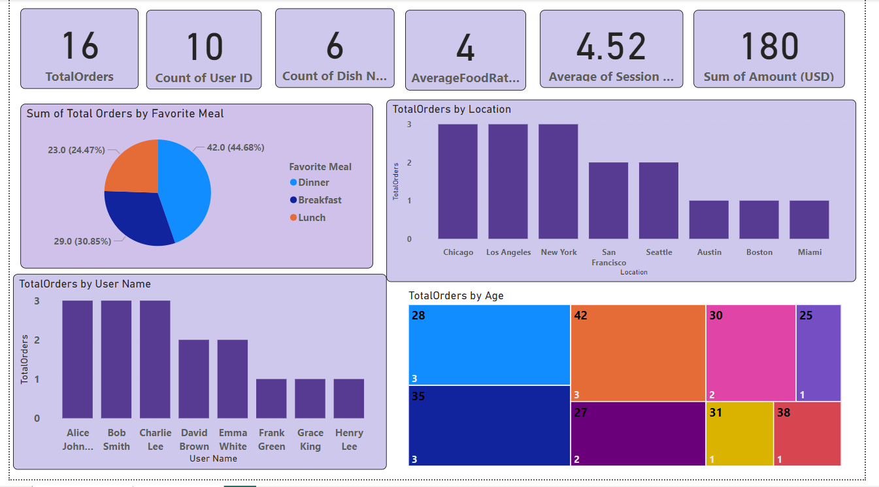**Customer Report**

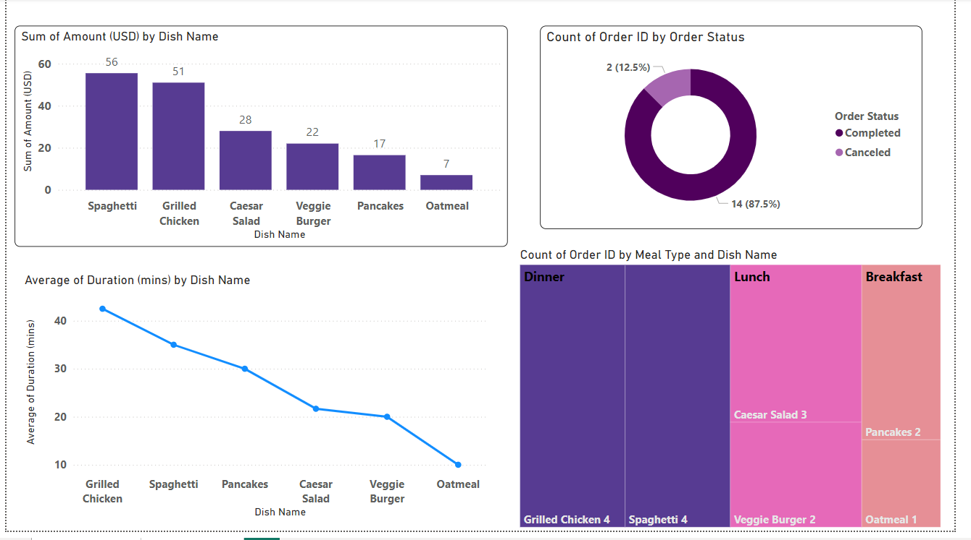**Product Report**